The address of the paper expresses its theme and its content
The name of the first author and the name of the second author * and the name of the third author **
The institution to which the first researcherbelongs
* The institution to the second researcherbelongs
** The institution that to the third researcherbelongs
Contact Information: E-mail: username@website.dom, …

2 Blank Lines
ABSTRACT
This document provides a model for writing a scientific paper for The Araid Journal of Science and Technology, issued by the Higher Institute of Science and Technology-AlShmokh. The title and abstract of the research paper are one of the most important parts. The title and abstract give the first impression of the research paper, and therefore must be drafted correctly and accurately. Most readers just care about reading the title and abstract of the research paper. The address must be descriptive, direct, accurate, appropriate and exquisite. The abstract must be simple, specific, clear, and stand-alone. The abstract is written using Microsoft Word (MSWord),font type (Times New Roman) and size12 points. The abstract should contain items that entrusted the content and should not exceed 250 words. It should include the problem of research and methodology, and the most important results obtained, with the most important conclusions reached in the research. It is good to formulate the abstract in a way that enables the reader to fully understand it, focusing on the original research, not on other researches. The abstract must be clear and understandable without referring to other sources. The abbreviations should also be avoided as much as possible, using the passive voice and avoid personal pronouns.
When writing a research paper in Arabic, it is requested to include an abstract in English at the forefront of research paper.
KEYWORDS: Remember that many database systems will reach the paper through the keywords listed, address and abstract.
1 Blank Line
- INTRODUCTION
In addition to the background of the subject and the motives of its studies, the introduction must contain a clear mention of the problem of research, and exposure to some previous studies dealing with the subject of research and the objectives that have been achieved.
The participation should be clearly characterized by spelling and grammar. The research paper submitted will be reviewed before published by referees, to ensure that the authors comply with the approved formal and substantive publishing conditions, according to a pre-prepared arbitration form for this purpose.
The identity of the authors must also be concealed in an effort by the editorial board to the utmost degree of impartiality by the reviewers.
References should be referred to and mentioned like [1, 2, 3]. References must be numbered in the order they appear in the text.
The number of research paper pages must be ( 8 - 16 ) pages.
- CONTENT DRAFTING
The highest levels of objectivity and scientific honesty must be pursued, staying away from commercial propaganda, or the method of defamation of persons, institutions and bodies.
After the title and abstract, it is required that the participation contain an introduction explaining the background of the topic and the motives for its study, followed by the presentation of the topic and its aspects with analysis and discussion.
  - Content Format
After completing the formulation of the research content, researchers are asked to apply the formal criteria required by the journal’s editorial board to the research submitted for publication, either by using this document as a template for placing the content prepared by researchers, or by applying the specifications required by the editorial board to each element of the text, which are as follows:
  - Page and Font Setup
Before printing the research paper, a custom size paper must be used with dimensions of 20 cm for width and 28.5 cm for length, and the page margins should be as follows:
- Top margin 2.5 cm.
- Bottom margin 2.5 cm.
- Right margin = Left margin = 2.5 cm.
Writing must be in one column, and all paragraphs must be justified from both the left and right sides. Font type must be (Times New Roman) normal for both Arabic and English writing. The font size must be 14 points for Arabic and 12 points for English. This applies when writing numbers and numbers in Arabic or English as well as mathematical signs and symbols such as (':', ';','%'...etc.), whenever needed to be used.
The line space of all paragraphs and Figure titles must be single, and spaces: Before: 0, After: 6 points. However, in Table titles, Before: 6, After: 0.

The type and size of the font must be adhered to when writing the research elements, as shown in Table (1).
Table 1: Font size used in the research papers.
Element | Bold | Font size (Arabic) | Font size (English)
Research Title | √ | 16 | 14 CAPITAL
Author(s) Name(s) | √ | 14 | 12
Author(s) Affiliation(s) |  | 13 | 11
Main Titles | √ | 14 | 12 CAPITAL
Sub Titles | √ | 13 | 11Capitalize Each Word
Text size |  | 14 | 12
Tables and Figures Caption | √ | 13 | 11
Tables Text |  | 10 | 11
Equations |  | Unified size (8 points) Normal

- TABLES AND FIGURES FORMAT
Figures are an excellent mechanism for expressing the idea of research results. Clear and good figures should be displayed. It must also be ensured that all the tables and figures included in the research have been referred to in the body of the research. Figures and tables should be displayed as close as possible to where they are first mentioned in the text and numbered sequentially and the titles of the tables should be written as indicated in Table (1). The captions of the figures must be written as shown in Figure (1).
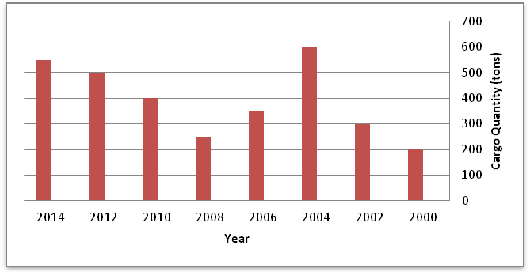
Figure 1: The amount of goods transported during the study period.
- CONCLUSION AND RECOMMENDATIONS
This template can be used to format the content of the post so that it meets the conditions of publication in the journal. If the template is not used, please consider the details provided above.
Copyright Reminder
For any material included in a paper that is copyrighted, the authors of the research are responsible for obtaining the copyright permissions, including any information requested by the copyright holder, and are able to produce those permissions upon request.
List ofSymbolsandAbbreviations
The list of symbols and abbreviations should be listed after the conclusion is written, and before the references.
REFERENCES
The citation for each reference should appear in the references section. Citations must be numbered consecutively using square brackets [1]. Sentence numbering is followed by parentheses [2]. Multiple references [2, 3] or a range of references [4-7] must appear within one set of parentheses. In sentences, simply indicate the reference number, as in [8]. Reference numbers should be assigned in the same order as given in the text. References should be in a separate section at the end of the paper.

- Author, (publication year), book title, place/city, publisher (book).
- Author, (publication year), article title, journal title, volume (issue), pages (journal).
- Author. (Publication year). Title of the article. Date Retrieved (date) from website (www.website.xxx)
- Ding, W. and Marchionini, G. 1997. A Study on Video Browsing Strategies. Technical Report, University of Maryland at College Park.
- Forman, G. 2003, An extensive empirical study of feature selection metrics for text classification. J. Mach. Learn. Res. 3 (Mar. 2003), 1289-1305.
- Yu, Y. T. and Lau, M. F. 2006. A comparison of MC/DC, MUMCUT and several other coverage criteria for logical decisions. J. Syst. Softw. 79, 5 (May. 2006), 577-590. DOI= http://dx.doi.org/10.1016/j.jss.2005.05.030.

